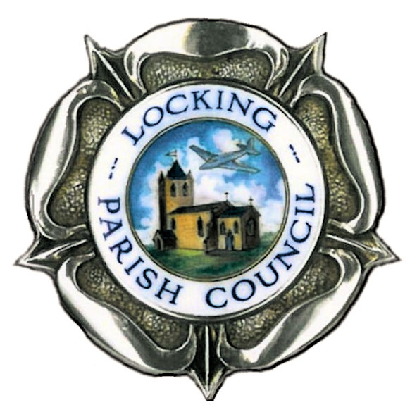
Parish Hall and Nurse Thomas Suite Hire
Terms and Conditions

HIRER RESPONSIBILITIES

- A key code will be issued to the hirer for access to the hall/Nurse Thomas Suite. This code is confidential and must not be shared with anyone else.

- All windows should be closed, and all entrance/exit doors must be locked securely after the event.

- Sub‑letting is not permitted under any circumstances.
- Nurse Thomas Suite use is restricted to adult organisations, unless special permission is granted by LPC.
- Maximum Capacity - Hall: 140 people. Nurse Thomas Suite: 25 people.
- Payments should be made by bank transfer at least 14 days prior to your event.
- Cancellations must be made verbally in the first instance and confirmed in writing to the parish office.

  - More than 14 days’ notice: no charge.
  - Between 48 hours and 14 days’ notice: 50% of the hire fee may be charged.
  - Less than 48 hours’ notice: the full hire fee may be charged.
  - Exceptional circumstances: the Council may waive charges at its discretion.
- Deposits
A £50 refundable deposit (cash or cheque) is required for all non-regular hirers. The Council reserves the right to retain all or part of the deposit if the hall/Nurse Thomas Suite is not left clean, undamaged, or if any regulations have been breached.
- Cleaning and rubbish disposal
The area hired must be left clean and tidy. Tables and chairs must be returned to their original positions. Hirers are responsible for removing all of their own rubbish from the premises at the end of their booking.

SAFETY REGULATIONS
- Electrical Safety - Any electrical equipment brought into the building must be safe and PAT‑tested.
- Kitchen Use - The kitchen is for food and drink preparation only.
- Damage must be reported immediately. Damage beyond normal wear will be charged to the hirer.
- Piano
The piano must not be moved. Any damage or injury caused by moving it is the hirer’s responsibility and not covered by the Council’s insurance.
- Equipment Use
Hirers wishing to use the hearing loop, microphone or sound system/speakers must notify the parish office in advance.
- Stage Use
The stage is for performances and authorised activities only. Children may only be on the stage when directly supervised by a responsible adult.
- Heating Controls - radiators and boiler controls must not be adjusted. Thermostats can be adjusted for temperature control but must be turned off at the end of the booking.

- Insurance
Hirers must arrange their own Public Liability Insurance for any personal items or activities brought into the building.
- Hirer’s Property - The Council accepts no responsibility for loss, damage, or theft of hirers’ property.
- LEGAL REQUIREMENTS

- No smoking or vaping - The entire building is a no smoking premises.
- Fire exits and stewarding
All exits, corridors, and gangways must be kept clear at all times. Fire exit doors must not be obstructed. Vehicles must not park in a way that blocks or restricts access to any fire exit outside the building.
The hirer must brief attendees on fire exits. At least two stewards must supervise fire exits. An additional two stewards must support disabled attendees.
- Admission control and accessibility
Admission must not be controlled in a way that blocks or restricts access to the entrance or any fire exit. Barriers, tables, or queueing systems must not be placed in front of doors or in escape routes.
Hirers must ensure safe access for all attendees, including those with disabilities, and must support evacuation where required.
- Emergency lighting - Exit signs will illuminate automatically in the event of a power failure.
- Emergencies - In any emergency situation, dial 999 immediately. Do not attempt to contact the parish office or councillors before calling the emergency services.
- Decorations and props
No inflammable or explosive materials. Decorations must be fire‑retardant. Nothing may be fixed to walls using nails, screws, tape, or Blu‑Tack.
- Seating and furniture
When chairs are used for audiences, they must be set out in a safe, theatre-style layout with clear gangways and unobstructed access to all exits. After use, chairs must be returned to the sides of the Hall and stacked safely.
- Safeguarding
Groups involving children or vulnerable adults must have: a safeguarding policy; adequate supervision; DBS‑checked staff where required.
- Data protection (GDPR)
Personal data provided on booking forms will be used only for managing bookings and will be stored in line with the Council’s GDPR policy.

Declaration - I acknowledge receipt of the terms and conditions and agree to comply with them.

Name |  | Signed
Organisation  (if applicable) |  | Date

Parish office contact details:
Locking Parish Council, Parish Hall, Grenville Avenue, Locking, BS24 8AR
Email: admin@lockingparishcouncil.gov.uk Tel: 01934 820786

